Abstract

AVR 2006 Design Contest
Entry registration number: AT3283
Entry title: Positional Sensor Interface
Product: Atmega16

Copyright 2006 by Chuck Baird, http://www.cbaird.net
All rights reserved

Description

This project implements and demonstrates an interface which supports up to 3 moderately precise non-contact XY sensors, 3 low resolution rotational sensors, and 9 switches using a simple protocol on a single communications channel. It was developed primarily to provide low cost and easily implemented sensors for homebrew robotics projects. The project includes 2 simple demonstration applications which utilize the interface.

The project uses the ATmega16 and the STK500 AVR Starter Kit because the author had both on hand. Any of several other AVR controllers would have sufficed, but the author chose not to sacrifice his AVR Butterfly because of its inherent cuteness.

The sensors which the interface controls are components in one to three inexpensive (under $10 each) optical scroll mice. Each mouse has 3 switches, a scroll wheel, and an optical XY sensor. A typical use envisioned for this interface might have the mouse (or its extracted innards) in a stationary mounting, with some external surface passing in front of its optics to provide the relative motion which is detected and reported.

It is assumed that this interface would most often be used with another microcontroller as its host, and for that reason the communications channel would logically be at digital signal levels. However, because the STK500 includes an easily accessible spare RS-232 capability, this method was chosen for the communications link to the host. RS-232 also had the advantage of simplifying debugging, and all features of the finished interface may be fully utilitized via terminal software.

The mice are wired directly to the AVR, so the interface consists of no external components. In this project the mice are powered with an external 5v supply since it isn’t clear what it takes to fry the STK500 power capabilities. Implementing the interface by itself would be the cost of the AVR and the RS232 level converter (unless a digital I/O scheme were used instead), plus power, reset, etc.

A simple command language is implemented which allows the host to control and interrogate the interface and unused AVR I/O pins (mice use 2 pins each). Mouse button events can also be recognized by the interface and mapped to the I/O pins (in a variety of formats) without the need of host intervention. For example, the interface by itself could light an LED or signal other hardware when a switch is closed.

To demonstrate some of the features of the interface, two devices have been cobbled together along with some simple PC host software. These demonstrations, while possibly short on practicality, should give a flavor of the types of uses the interface may find.

The MouseMobile demonstates two mice in fairly conventional use. Built in the guise of a car, its host software displays a graphic trace of its position as it moves and rotates. Acting as a digitizer and distance measurer, it can also locate the midpoint of an arbitrarily drawn curve.

The Mousitizer is a polar coordinate digitizer and demonstrates how the interface can use an XY sensor to detect rotational motion and the rotational sensor to detect linear motion.

Project Photograph

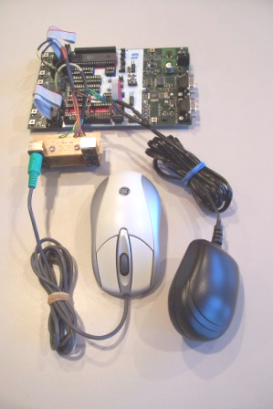

The AVR STK500 Starter Kit with a block of four PS/2 connectors scavenged from an old KVM swith. The power supply is used to power the mice via the PS/2 connectors.
Block Diagram

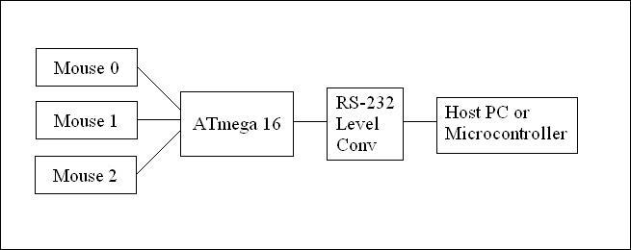

The interface supports 3 mice.
The Batmobile Wannabe demonstration uses 2 unmodified mice.
The Mousitizer demonstration uses 1 mouse which has been disassembled and parts strewn asunder.

Software Code Sample

The entire interface (AVR code) was written in assembly language using AVR Studio 4. All code is original. The host PC programs for the two demonstrations were written in Visual Basic.

Part of the mouse interrupt handler:

; ==============================================
; mint2 - mouse interrupt handler, part deux
;
; mouse number will be in r0 (0, 1, or 2)
; r16 may be used without save/restore (caller does it)
; end with ret, not reti
;
; status: 0 - idle (initial and after read or write)
; 1 - sending setup in progress (ignore interrupts)
; 2 - sending data
; 3 - receiving data
; 4 - received stop bit (ok for new receive, but
; if sendmouse sees this it has to wait for
; the line to go high
; 5 - waiting ack for send

mint2: push ZH
push ZL

rcall moff2z
ldd r16,Z+mo_sts ; current line status
push r16 ; it's arg to jumptable
rcall jumptable
rjmp strtrecv ; 0 - this int's a start bit
rjmp ignore ; 1 - ignore (sendmouse did it)
rjmp sendbits ; 2 - we're clocking bits out
rjmp recvbits ; 3 - we're clocking bits in
rjmp strtrecv ; 4 - it's a start bit
rjmp waitack ; 5 - it's the send ack

; ---------------------------------
; the line is idle or we recvd a stop bit on the last clock (4),
; and we've had a falling edge. the mouse is sending us a start bit
strtrecv: ; it's a start bit for receive
rcall startofbyte ; packet mgmt
ldi r16,3 ; should wrap up in a couple ms
rcall starttimer
clr r16
std Z+mo_r,r16 ; received byte = 0
std Z+mo_rc,r16 ; received bit count = 0
std Z+mo_rp,r16 ; received parity = 0
ldi r16,3 ; status: receive in progress
std Z+mo_sts,r16

ignore: pop ZL
pop ZH
ret

; ---------------------------------
; reading bits from the mouse (data, parity, stop)
recvbits:
ldd r16,Z+mo_rc ; # bits received so far
inc r16 ; count this one
std Z+mo_rc,r16

cpi r16,9
breq pbit ; if 9, this is parity bit
brcs dbit ; if <9, it's a data bit

ldd r16,Z+mo_r ; doggies, it's the stop bit
push XH
push XL
rcall mhinc2x ; point to buffer head w/ inc
st X,r16 ; put our byte away
pop XL
pop XH
rcall endofbyte ; packet mgmt

A piece of the main command processor:

; --------------------------------
cmd_3: rcall chkmouse ; 'B' 1 byte: read switches
breq sendnak ; mouse not initialized

rcall moff2z
ldd r16,Z+mo_but ; buttons and overflows
mov r1,r16 ; save. YX---MRL is order
lsr r16 ; building -----LMR
andi r16,0x03 ; keep MR
sbrc r1,0
sbr r16,0x04 ; put L back in

rcall bin2hex
push r16 ; arg to xmit_put
rcall xmit_put
rjmp sendack
; --------------------------------
; for output, set DDR <- 1
cmd_4: rcall prepport ; 'D' 2 bytes: DPort - port to output
breq sendnak4 ; zero set means port error

lds XL,pindef+w_ddr ; DDR address for this port
clr XH ; they're small addresses
ser r16
st X,r16 ; all bits set
rjmp sendack
; --------------------------------

Schematic

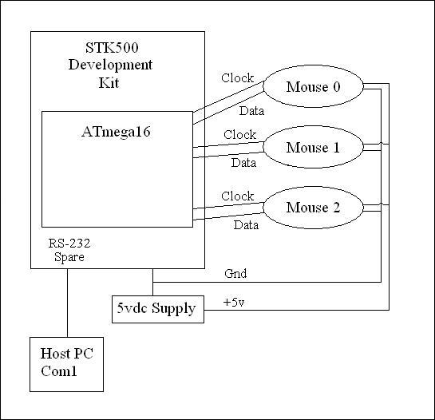

Circuitry added to STK500:
3 mice
External 5vdc power supply

Mice connect to the Atmega16 through the STK500 port connections:
Mouse 0 clock Port D, bit 2 (Int 0)
Mouse 0 data Port D, bit 4
Mouse 1 clock Port D, bit 3 (Int 1)
Mouse 1 data Port D, bit 5
Mouse 2 clock Port B, bit 2 (Int 2)
Mouse 2 data Port B, bit 0

Other STK500 connections:
Spare RS232 Tx Port D, pin 0 (TxD)
Spare RS232 Rx Port D, pin 1 (RxD)
LEDs Port C
Switches Port A

